Reviewer Note: Reviews for this pattern are due Sept 21st.
JDBC for Reading

In an EJB system that uses a relational database in the backend, an EJB client needs to populate a tabular user interface (UI) with server side data, for display purposes.

When should a session façade perform direct data base access instead of going through the entity bean layer?
* * *
Perhaps the most common use case in distributed applications is the need to present static server-side data to a client in tabular form. Examples of tabular UI’s are the majority of web pages, where data is listed in tables or rows, such as a list of items in a catalogue (as opposed to non-tabular UI’s such as the rare tree like or circular UI). Furthermore, this tabular data is usually read-only; clients tend to do a lot more browsing than updating the pages they surf.
One common scenario is an application that requires the presentation of a large amount of read-only data to the user, perhaps in the form of an HTML table. The table may represent line items in a large order, information on all employees in a company, or the characteristics of all products a company produces.
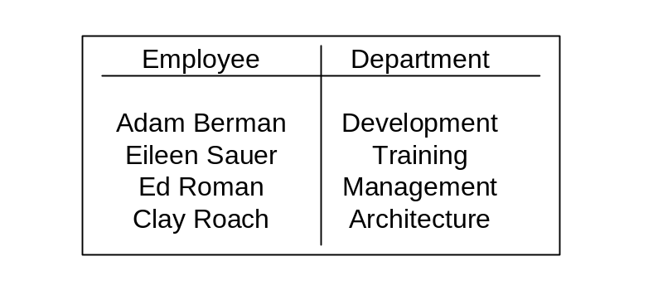

Figure X.1: HTML Table of Employees

In figure 1, each row in the table corresponds to one employee in the system and his/her department. On the server side, we would model this with an Employee and a Department entity bean. One way to populate the table would be to call a getEmployees() method on a Session Façade/Data Transfer Object Factory, which would call a finder method on an EmployeeHome object, return all employee’s, find each employee’s related department entity bean, and create a Custom Data Transfer Object with the combined data from these two entity beans. The session bean would then return a collection of EmployeeDepartmentDTO’s to the client.
Depending on the EJB Server and applications, there are numerous problems with this approach:
The n+1 entity bean database calls problem. With BMP and certain implementations of CMP, retrieving data from N entity beans will require N+1 database calls. Although a good CMP implementation will allow bulk loading, developers should be aware of this dire problem. The N+1 calls problem is as follows: In order to read data from N entity beans, one must first call a finder method (one database call). The container will then execute ejbLoad() individually on each entity bean returned by the finder method, either directly after the finder invocation or just before a business method invocation. This means that ejbLoad() (which will execute a database call) will need to be called for each entity bean. Thus, a simple database query operation requires N+1 database calls when going through the entity bean layer! Each such database call will temporarily lock a database connection from the pool, open and close connections, open and close result sets, etc. Since most distributed systems have a separate box for the database, each of these database round trips would require a network call, slowing down the speed of each round trip and locking valuable database resources from the rest of the system. For our Employee and Departments example, running this use case will actually require 2N+1 database calls (1 finder, N Emlpoyee ejbLoads(), and N Department ejbLoads()).
Remote Call overhead. If going through the entity bean remote interface (as opposed to the local interface), this method would also require 3N remote calls for N rows of employee and department data. The remote calls break down as follows:
N calls to getValueObject() for each Employee.
N calls to getDepartment() on each Employee.
N calls to getValueObject() on each Department.
All after grabbing each set of Value Objects, the Session bean would then combine the value objects into the EmployeeProjectViewObjects.
Cumbersome for simple join operations. Be it BMP or CMP, this typical use case requires the instantiation of multiple entity beans and traversal of their relationships. Imagine a slightly more complex scenario where the table needed to list data from an Employee and related Department, Project and Company. This would not only require tens of lines of spaghetti code, but would significantly slow down a system, due to the database calls, remote calls, and all the application server overhead incurred when traversing multiple entity bean relationships.
When the client side mainly requires tabular data for read only, listing purposes, the benefits of querying through the entity bean layer are less clear. Using local interfaces and a good CMP implementation will definitely reduce the performance problems with listing data via entity beans, but BMP developers are not so lucky. In BMP, these problems can only be alleviated by turning on entity bean caching, a luxury usually only available for single EJB server (aka non-clustered) deployments in which the database is never modified outside of the EJB app. The remaining BMP developers are faced with a serious performance problem. Querying through the entity bean layer for simply listing of read only data causes unacceptable performance problems
Therefore,
In BMP, perform listing operations on relational databases using JDBC. Use Entity Beans for update operations.
If the data that the client UI requires is mainly used for ‘listing’ purposes, then using JDBC to directly read the rows and columns required by the client can be far faster and more efficient then going through the entity bean layer. Using the previous example, the entire table of employees and departments could be bulk-read in just one JDBC call from the database, as opposed to the potentially required 3N remote calls and N+1 database calls in-required if reading through the entity bean layer.
After reading in the ResultSet, the data could then be added to EmployeeDepartmentDTO’s just as in the previous example, or it could be marshaled to the client using HashMaps (as in Data Transfer HashMap) or in tabular form using RowSets, as in the Data Transfer Rowset pattern.
The decision to use straight JDBC instead of entity beans for reading data is a tough one for most developers, and has been the subject of raging debates since the advent of entity beans. After all, entity beans provide a nice encapsulation of data and data logic, they hide the persistence details such as the type of database being used, they model the business concepts in your system and make use of many container features such as pooling, concurrency, transactions, etc. To go to a non-OO method of data access seems like a step back. Like all design patterns, there are tradeoffs.
Using JDBC for reading purposes as the following advantages:
No transactional overhead for simple query operations. Read only operations do not need to use transactions. Querying the database from a stateless session bean with transactions turned off is more lightweight than querying entity beans. Often it is impossible to query an entity bean without a transaction.
Takes advantage of DB built in caching. Databases have sophisticated and powerful caches. By using JDBC for these operations we can make better use of the DB’s built in cache. This becomes important when executing queries that span tables, as the database can cache the results of this one bulk query, rather than cache individual table queries generated by entity bean ejbLoads calls. The next time a query is run, the one bulk JDBC query will come directly from the database cache.
Retrieve the exact data your use case requires. Using JDBC, you can select the exact columns required across any number of tables. This stands in contrast with using an entity bean layer, in which the client may only need a couple of attributes from a variety of related entity beans. Those entity beans will need to load all of their attributes from the database even if a client only needs one attribute.
Perform queries in ONE BULK READ. All the data a client requires is grabbed in one bulk database call. This is in direct contrast to the N+1 database calls problem associated with entity beans.
Here are the tradeoffs:
Tight coupling between business and persistence logic. When working with an entity bean, a developer doesn’t know what the underlying persistence mechanism is. With this pattern, Session Bean data querying logic is now coupled to the JDBC API’s and is thus coupled to a relational database. However, other Design Patterns such as Data Access Object (not covered in this book) can be used to alleviate this problem.
Bug prone and less maintainable. Bug prone JDBC code is now mixed around the session bean layer, instead of nicely encapsulated behind entity beans. Changes to the database schema will require changes to multiple code fragments across the Session Façade. Again, the Data Access Object pattern can help here.

Finally, this pattern does not imply that entity beans should not be used at all, only that there are more efficient alternatives when the client needs to temporarily list data. In this pattern, JDBC is used for listing behavior, and the entity bean layer is used for updating behavior in an application.
Whereas the integrity business/data objects and their relationships with other business objects are not that important when listing tables of ‘data’ on a client, these concepts are critical when performing updates. Entity beans (or any other data object framework) encapsulate both data and rules for changing that data. When updating an attribute on an entity bean, the entity bean may need to perform validation logic on its changes and institute updates on other entity beans in an application.
For example, consider an application with Book and Chapter entity beans. When modifying the title of a Chapter entity bean, the Chapter will need to perform validation on the new title, and internally call and modify its Book bean to notify it to change its table of contents. The Book entity bean may then need to modify other entity beans, etc.
Performing updates via JDBC from the Session Façade forces a developer to write a spaghetti code that mixes business logic with the complexities of data logic. All the rules, relationships and validations required by particular business concepts would have to be hacked in the form of updates on rows and tables. The system would become very brittle to changes in the business requirements of the application.
Thus, where the client UI requires read-only tabular data and entity bean caching is not possible, use JDBC to read in data from the database, instead of going through the entity bean layer. All updates should still go through the domain object (entity bean) layer.
The JDBC for Reading pattern occurs behind a Session Façade or a Data Transfer Object Factory. Depending on what type of object is used to transfer the ResultSets contents to the client. (DTO Factory implies that DTO’s will be returned to the client, whereas HashMaps or RowSets can be returned from the Session Façade).

